Brain Tumour Image Segmentation Using Deep Networks
1. INTRODUCTION:
Brain tumors are among the most critical and life-threatening medical conditions, requiring early detection and accurate diagnosis for effective treatment. Magnetic Resonance Imaging (MRI) is a widely used non-invasive technique to capture detailed brain scans, providing essential insights for identifying abnormalities. However, manual analysis of these images is time-consuming, prone to errors, and highly dependent on the expertise of radiologists.
To address these challenges, automated image segmentation and classification systems have emerged as a promising solution. Image segmentation, particularly in the context of brain tumors, involves isolating and identifying tumorous regions from MRI scans. This process is essential for precise diagnosis, surgical planning, and monitoring disease progression.
In recent years, deep learning techniques, especially Convolutional Neural Networks (CNNs), have revolutionized the field of medical image analysis. CNNs excel in processing and extracting features from complex image datasets, making them highly suitable for brain tumor segmentation. By leveraging CNNs, this project aims to automate the detection and segmentation of brain tumors with a high degree of accuracy.
This project employs a CNN-based architecture trained on a dataset containing brain images with and without tumors. The proposed system is designed to classify and segment tumors effectively, enabling healthcare professionals to make timely and informed decisions. The model's robust performance, coupled with its scalability, positions it as a vital tool in modern medical imaging workflows.
1.1 Objective of the project:
Brain tumor image segmentation is a critical task in medical imaging, enabling early detection and precise treatment planning. This project implements a deep learning-based approach using Convolutional Neural Networks (CNN) to predict and classify brain tumors. The model is trained on a dataset comprising brain images with and without tumors, ensuring robust feature extraction and accurate segmentation.
The CNN architecture is designed to capture intricate patterns in the brain images, distinguishing between healthy and tumorous tissues effectively. The system undergoes rigorous preprocessing, including normalization and data augmentation, to improve model generalization and handle variability in the dataset.
Experimental results demonstrate the efficiency of the proposed CNN model in achieving high accuracy in brain tumor detection, highlighting its potential for assisting healthcare professionals in clinical decision-making. Future work involves enhancing the model's capabilities with more advanced architectures and extending its application to real-time diagnostic tools.
This approach not only automates the detection process but also significantly reduces the workload on radiologists, paving the way for scalable and efficient medical imaging solutions.

2. LITERATURE SURVEY:
“Long-bone fracture detection in digital X-ray images based on digital-geometric techniques.”
Automated fracture detection is an essential part of a computer-aided tele-medicine system. In this paper, we have proposed a unified technique for the detection and evaluation of orthopaedic fractures in long-bone digital X-ray image. We have also developed a software tool that can be conveniently used by paramedics or specialist doctors. The proposed tool first segments the bone region of an input digital X-ray image from its surrounding flesh region and then generates the bone-contour using an adaptive thresholding approach. Next, it performs unsupervised correction of bone-contour discontinuities that might have been generated because of segmentation errors, and finally detects the presence of fracture in the bone. Moreover, the method can also localize the line-of-break for easy visualization of the fracture, identify its orientation, and assess the extent of damage in the bone. Several concepts from digital geometry such as relaxed straightness and concavity index are utilized to correct contour imperfections, and to detect fracture locations and type. Experiments on a database of several long-bone digital X-ray images show satisfactory results.
“Automatic segmentation of bones in X-ray images based on entropy measure.”
In this paper, we introduce an efficient method for segmenting the bone region of an X-ray image from its surrounding muscles and tissues. Automated segmentation of the bone part in a digital X-ray image is a challenging problem because of its low contrast with the surrounding flesh. The presence of noise and spurious edges further complicates the segmentation. Most of the existing methods either suffer from noisy contour detection or need training samples for manual tuning of certain thresholding parameters. We propose a fully automated segmentation technique, which utilizes a variant of entropy measure of the image. This scheme has been shown to be useful for fast and efficient analysis of a wide class of human X-ray images including skull, chest, pelvic region and ortho-dental zones. In order to quantify the quality of segmentation, we propose a new metric called average contour distortion index (ACDI) based on certain neighborhood properties of the contour pixels. Experiments on several X-ray images reveal encouraging results compared to other approaches as evident from the ACDI metric. We also re-validate the quality of several segmented bone images using segmentation entropy quantitative assessment (SEQA), and boundary-based precision–recall profile. All three metrics establish the superiority of the proposed technique to prior art.
“On the measurement of curvature in a quantized environment.”
Some aspects of the application of the mathematical concept of curvature as a practical descriptor of shape for pattern recognition and image processing applications are investigated.
“Multimodal bone cancer detection using fuzzy classification and variational model.”
Precise segmentation of bone cancer is an important step for several applications. However, the achievement of this task has proven problematic due to lack of contrast and the non homogeneous intensities in many modalities such as MRI and CT-scans. In this paper we investigate this line of research by introducing a new method for segmenting bone cancer. Our segmentation process involves different steps: a registration step of different image modalities, a fuzzy-possibilistic classification (FPCM) step and a final segmentation step based on a variational model. The registration and the FPCM algorithms are used to locate and to initialize accurately the deformable model that will evolve smoothly to delineate the expected tumor boundaries. Preliminary results show accurate and promising detection of the cancer region.
“A tutorial on support vector machines for pattern recognition”
The tutorial starts with an overview of the concepts of VC dimension and structural risk minimization. We then describe linear Support Vector Machines (SVMs) for separable and non-separable data, working through a non-trivial example in detail. We describe a mechanical analogy, and discuss when SVM solutions are unique and when they are global. We describe how support vector training can be practically implemented, and discuss in detail the kernel mapping technique which is used to construct SVM solutions which are nonlinear in the data. We show how Support Vector machines can have very large (even infinite) VC dimension by computing the VC dimension for homogeneous polynomial and Gaussian radial basis function kernels. While very high VC dimension would normally bode ill for generalization performance, and while at present there exists no theory which shows that good generalization performance is guaranteed for SVMs, there are several arguments which support the observed high accuracy of SVMs, which we review. Results of some experiments which were inspired by these arguments are also presented. We give numerous examples and proofs of most of the key theorems. There is new material, and I hope that the reader will find that even old material is cast in a fresh light.
“Decision forests for computer vision and medical image analysis”
We present a unified framework involving the extraction of random subwindows within images and the induction of ensembles of extremely randomized trees. We discuss the specialization of this framework for solving several general problems in computer vision, ranging from image classification and segmentation to content-based image retrieval and interest point detection. The methods are illustrated on various applications and datasets from the biomedical domain.
“MR Imaging in staging of bone tumors”
Rotator cuff tears are common conditions that often require surgical repair to improve function and to relieve pain. Unfortunately, repair failure remains a common problem after rotator cuff repair surgery. Several factors may contribute to repair failure, including age, tear size, and time from injury. However, the mechanical mechanisms resulting in repair failure are not well understood, making clinical management difficult. Specifically, altered scapular motion (termed scapular dyskinesis) may be one important and modifiable factor contributing to the risk of repair failure. Therefore, the objective of this study was to determine the effect of scapular dyskinesis on supraspinatus tendon healing after repair.A rat model of scapular dyskinesis was used. Seventy adult male Sprague-Dawley rats (400-450 g) were randomized into 2 groups: nerve transection of the accessory and long thoracic nerves (SD) or sham nerve transection (Sham control). After this procedure, all rats underwent unilateral detachment and repair of the supraspinatus tendon. All rats were sacrificed at 2, 4, and 8 weeks after surgery. Shoulder function, passive joint mechanics, and tendon properties (mechanical, histologic, organizational, and compositional) were evaluated.Scapular dyskinesis alters joint function and may lead to compromised supraspinatus tendon properties. Specifically, diminished mechanical properties, altered histology, and decreased tendon organization were observed for some parameters.This study identifies scapular dyskinesis as one underlying mechanism leading to compromise of supraspinatus healing after repair. Identifying modifiable factors that lead to compromised tendon healing will help improve clinical outcomes after repair.
“Segmentation of bone tumor in MR perfusion images using neural networks and multiscale pharmacokinetic features”
The decrease in the volume of viable tumor is an indicator for the effect preoperative chemotherapy has on bone tumors. We develop an approach for segmenting dynamic perfusion MR-images into viable tumor, nonviable tumor and healthy tissue. Two cascaded feedforward neural networks are trained to perform the pixel-based segmentation. As features, we use the parameters obtained from a pharmacokinetic model of the tissue perfusion (parametric images). Additional multiscale features that incorporate contextual information are included. Experiments indicate that multiscale blurred versions of the parametric images together with a multiscale formulation of the local image entropy are the most discriminative features
“On the encoding of arbitrary geometric configurations.”
A method is described which permits the encoding of arbitrary geometric configurations so as to facilitate their analysis and manipulation by means of a digital computer. It is shown that one can determine through the use of relatively simple numerical techniques whether a given arbitrary plane curve is open or closed, whether it is singly or multiply connected, and what area it encloses. Further, one can cause a given figure to be expanded, contracted, elongated, or rotated by an arbitrary amount. It is shown that there are a number of ways of encoding arbitrary geometric curves to facilitate such manipulations, each having its own particular advantages and disadvantages. One method, the so-called rectangular-array type of encoding, is discussed in detail. In this method the slope function is quantized into a set of eight standard slopes. This particular representation is one of the simplest and one that is most readily utilized with present-day computing and display equipment.
“Machine learning based analysis of gender differences in visual inspection decision making.”
While machine learning is most often concerned with learning from humans, the fact that human behavior systematically differs for (groups of) people with different gender, age, education or cultural background is widely ignored. Obviously, such differences are reflected in the training humans provide to machine learning algorithms that in turn affects the induced models. A coherent set of experiment design and analysis methods is presented which was applied for studying gender differences in visual inspection decision making. Detailed results from a study with 50 female and 50 male subjects are reported. Although immediate performance measures were almost equal, highly significant differences in the structure of induced decision trees have been found (p = 0.00005). This demonstrates the value of our contribution for researchers intending to investigate the otherwise hidden structure of cognitive gender differences rather than their merits.
3. SYSTEM ANALYSIS
3.1 EXISTING SYSTEM: X-ray image analysis provides one of the cheapest primary screening tools for the diagnosis of bone cancer. As reported in the medical literature a primary bone tumor usually appears with unsuspecting symptoms such as fracture of a bone, swelling around a bone, a new bone growth, or swelling in the soft tissues surrounding a bone. Oftentimes, an X-ray image of cancer-affected bone appears different from its surrounding healthy bones and flesh region. The X-ray absorption rate of bone cells in the cancer-affected region differs from that in healthy bone cells . As a result, the image of cancer-affected bones appears in the form of a “ragged” surface (permeative bone destruction), tumor (geographic bone destruction), or holes (moth-eaten pattern of bone destruction)
Disadvantages:
  - Low accuracy
  - a small increase in the possibility that a person exposed to X-rays will develop cancer later in life. ...
  - tissue effects such as cataracts, skin reddening, and hair loss, which occur at relatively high levels of radiation exposure and are rare for many types of imaging exams.

3.2 PROPOSED SYSTEM:
The retrospective study analyzed bone tumors on radiographs acquired prior to treatment from January 2000 to June 2020. Radiographs from 934 patients were evaluated including 667 benign bone tumors and 267 malignant bone tumors. Researchers used more than 600 cases to train the deep learning model and then 140 cases to validate and test it.The model achieved 80% accuracy and 88% specificity in the classification of bone tumors as malignant or benign. The models’ accuracy in classifying tumors as malignant or benign was higher than that of two fourth year radiology residents and was comparable with that of two highly experienced musculoskeletal fellowship-trained radiologists.
ADVANTAGES:
- High accuracy
- noninvasively and painlessly help to diagnose disease and monitor therapy;
- support medical and surgical treatment planning; and.
- guide medical personnel as they insert catheters, stents, or other devices inside the body, treat tumors, or remove blood clots or other blockages.
Modules Information:
In this project we are implementing deep learning Convolution Neural Network (CNN) to predict bone tumor and to train this algorithm we have used bone images with and without tumor.
To implement this project we have designed following modules
- Dataset upload: using this module we will upload dataset to application
- Dataset Preprocessing: using this module we will read all images and then convert them into GREY format and then resize all images to equal size and then normalize pixel values.
- Features Extraction: features or pixel values will be extracted from processed images and then input this features to CNN to trained tumor prediction model
- Segmentation & Classification: using this module we will read test image and then apply segmentation to extract tumor part and then predict weather image is normal or contains any tumor. Edge detection technique will be applied to surround bounding box across tumor part
3.3. PROCESS MODEL USED WITH JUSTIFICATION
SDLC (Umbrella Model):
Umbrella Activity
Umbrella Activity
Umbrella Activity
- Feasibility Study
- TEAM FORMATION
- Project Specification PREPARATION

Business Requirement Documentation
ANALYSIS & DESIGN
CODE
UNIT TEST
DOCUMENT CONTROL

ASSESSMENT

TRAINING
INTEGRATION & SYSTEM TESTING

DELIVERY/INSTALLATION
ACCEPTANCE TEST
Requirements Gathering
SDLC is nothing but Software Development Life Cycle. It is a standard which is used by software industry to develop good software.
Stages in SDLC:
- Requirement Gathering
- Analysis
- Designing
- Coding
- Testing
- Maintenance
Requirements Gathering stage:
The requirements gathering process takes as its input the goals identified in the high-level requirements section of the project plan. Each goal will be refined into a set of one or more requirements. These requirements define the major functions of the intended application, define operational data areas and reference data areas, and define the initial data entities. Major functions include critical processes to be managed, as well as mission critical inputs, outputs and reports. A user class hierarchy is developed and associated with these major functions, data areas, and data entities. Each of these definitions is termed a Requirement. Requirements are identified by unique requirement identifiers and, at minimum, contain a requirement title and textual description.
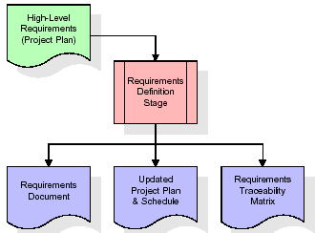
These requirements are fully described in the primary deliverables for this stage: the Requirements Document and the Requirements Traceability Matrix (RTM). The requirements document contains complete descriptions of each requirement, including diagrams and references to external documents as necessary. Note that detailed listings of database tables and fields are not included in the requirements document.
The title of each requirement is also placed into the first version of the RTM, along with the title of each goal from the project plan. The purpose of the RTM is to show that the product components developed during each stage of the software development lifecycle are formally connected to the components developed in prior stages.
In the requirements stage, the RTM consists of a list of high-level requirements, or goals, by title, with a listing of associated requirements for each goal, listed by requirement title. In this hierarchical listing, the RTM shows that each requirement developed during this stage is formally linked to a specific product goal. In this format, each requirement can be traced to a specific product goal, hence the term requirements traceability.
The outputs of the requirements definition stage include the requirements document, the RTM, and an updated project plan.
- Feasibility study is all about identification of problems in a project.
- No. of staff required to handle a project is represented as Team Formation, in this case only modules are individual tasks will be assigned to employees who are working for that project.
- Project Specifications are all about representing of various possible inputs submitting to the server and corresponding outputs along with reports maintained by administrator.
Analysis Stage:
The planning stage establishes a bird's eye view of the intended software product, and uses this to establish the basic project structure, evaluate feasibility and risks associated with the project, and describe appropriate management and technical approaches.
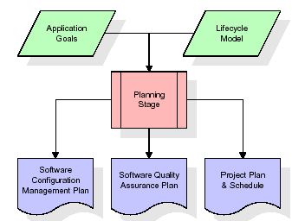
The most critical section of the project plan is a listing of high-level product requirements, also referred to as goals. All of the software product requirements to be developed during the requirements definition stage flow from one or more of these goals. The minimum information for each goal consists of a title and textual description, although additional information and references to external documents may be included. The outputs of the project planning stage are the configuration management plan, the quality assurance plan, and the project plan and schedule, with a detailed listing of scheduled activities for the upcoming Requirements stage, and high level estimates of effort for the out stages.
Designing Stage:
The design stage takes as its initial input the requirements identified in the approved requirements document. For each requirement, a set of one or more design elements will be produced as a result of interviews, workshops, and/or prototype efforts. Design elements describe the desired software features in detail, and generally include functional hierarchy diagrams, screen layout diagrams, tables of business rules, business process diagrams, pseudo code, and a complete entity-relationship diagram with a full data dictionary. These design elements are intended to describe the software in sufficient detail that skilled programmers may develop the software with minimal additional input.
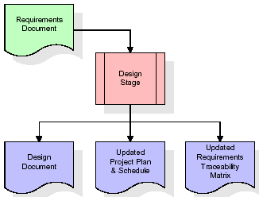
When the design document is finalized and accepted, the RTM is updated to show that each design element is formally associated with a specific requirement. The outputs of the design stage are the design document, an updated RTM, and an updated project plan.
Development (Coding) Stage:
The development stage takes as its primary input the design elements described in the approved design document. For each design element, a set of one or more software artifacts will be produced. Software artifacts include but are not limited to menus, dialogs, and data management forms, data reporting formats, and specialized procedures and functions. Appropriate test cases will be developed for each set of functionally related software artifacts, and an online help system will be developed to guide users in their interactions with the software.
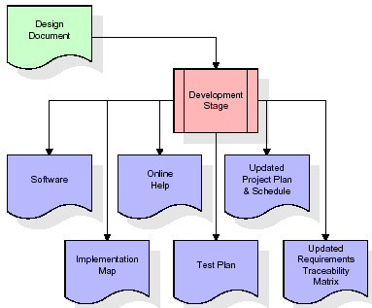

The RTM will be updated to show that each developed artifact is linked to a specific design element, and that each developed artifact has one or more corresponding test case items. At this point, the RTM is in its final configuration. The outputs of the development stage include a fully functional set of software that satisfies the requirements and design elements previously documented, an online help system that describes the operation of the software, an implementation map that identifies the primary code entry points for all major system functions, a test plan that describes the test cases to be used to validate the correctness and completeness of the software, an updated RTM, and an updated project plan.
Integration & Test Stage:
During the integration and test stage, the software artifacts, online help, and test data are migrated from the development environment to a separate test environment. At this point, all test cases are run to verify the correctness and completeness of the software. Successful execution of the test suite confirms a robust and complete migration capability. During this stage, reference data is finalized for production use and production users are identified and linked to their appropriate roles. The final reference data (or links to reference data source files) and production user list are compiled into the Production Initiation Plan.
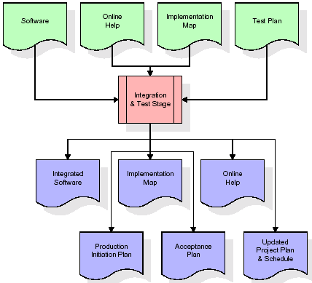
The outputs of the integration and test stage include an integrated set of software, an online help system, an implementation map, a production initiation plan that describes reference data and production users, an acceptance plan which contains the final suite of test cases, and an updated project plan.
- Installation & Acceptance Test:
During the installation and acceptance stage, the software artifacts, online help, and initial production data are loa ded onto the production server. At this point, all test cases are run to verify the correctness and completeness of the software. Successful execution of the test suite is a prerequisite to acceptance of the software by the customer.
After customer personnel have verified that the initial production data load is correct and the test suite has been executed with satisfactory results, the customer formally accepts the delivery of the software.
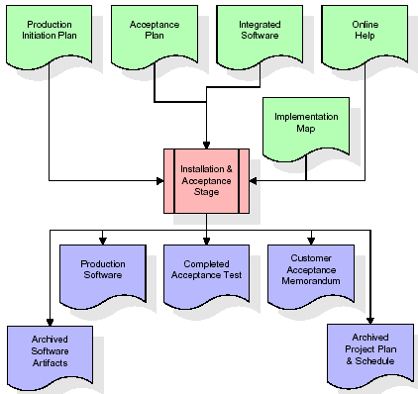
The primary outputs of the installation and acceptance stage include a production application, a completed acceptance test suite, and a memorandum of customer acceptance of the software. Finally, the PDR enters the last of the actual labor data into the project schedule and locks the project as a permanent project record. At this point the PDR "locks" the project by archiving all software items, the implementation map, the source code, and the documentation for future reference.
Maintenance:
Outer rectangle represents maintenance of a project, Maintenance team will start with requirement study, understanding of documentation later employees will be assigned work and they will undergo training on that particular assigned category. For this life cycle there is no end, it will be continued so on like an umbrella (no ending point to umbrella sticks).
3.4. Software Requirement Specification
3.4.1. Overall Description
A Software Requirements Specification (SRS) – a requirements specification for a software system is a complete description of the behavior of a system to be developed. It includes a set of use cases that describe all the interactions the users will have with the software. In addition to use cases, the SRS also contains non-functional requirements. Nonfunctional requirements are requirements which impose constraints on the design or implementation (such as performance engineering requirements, quality standards, or design constraints).
System requirements specification: A structured collection of information that embodies the requirements of a system. A business analyst, sometimes titled system analyst, is responsible for analyzing the business needs of their clients and stakeholders to help identify business problems and propose solutions. Within the systems development lifecycle domain, the BA typically performs a liaison function between the business side of an enterprise and the information technology department or external service providers. Projects are subject to three sorts of requirements:
- Business requirements describe in business terms what must be delivered or accomplished to provide value.
- Product requirements describe properties of a system or product (which could be one of several ways to accomplish a set of business requirements.)
- Process requirements describe activities performed by the developing organization. For instance, process requirements could specify .Preliminary investigation examine project feasibility, the likelihood the system will be useful to the organization. The main objective of the feasibility study is to test the Technical, Operational and Economical feasibility for adding new modules and debugging old running system. All system is feasible if they are unlimited resources and infinite time. There are aspects in the feasibility study portion of the preliminary investigation:
- ECONOMIC FEASIBILITY
A system can be developed technically and that will be used if installed must still be a good investment for the organization. In the economical feasibility, the development cost in creating the system is evaluated against the ultimate benefit derived from the new systems. Financial benefits must equal or exceed the costs. The system is economically feasible. It does not require any addition hardware or software. Since the interface for this system is developed using the existing resources and technologies available at NIC, There is nominal expenditure and economical feasibility for certain.
- Operational Feasibility
Proposed projects are beneficial only if they can be turned out into information system. That will meet the organization’s operating requirements. Operational feasibility aspects of the project are to be taken as an important part of the project implementation. This system is targeted to be in accordance with the above-mentioned issues. Beforehand, the management issues and user requirements have been taken into consideration. So there is no question of resistance from the users that can undermine the possible application benefits. The well-planned design would ensure the optimal utilization of the computer resources and would help in the improvement of performance status.
- TECHNICAL FEASIBILITY
Earlier no system existed to cater to the needs of ‘Secure Infrastructure Implementation System’. The current system developed is technically feasible. It is a web based user interface for audit workflow at NIC-CSD. Thus it provides an easy access to .the users. The database’s purpose is to create, establish and maintain a workflow among various entities in order to facilitate all concerned users in their various capacities or roles. Permission to the users would be granted based on the roles specified. Therefore, it provides the technical guarantee of accuracy, reliability and security.
3.4.2. External Interface Requirements
User Interface
The user interface of this system is a user friendly python Graphical User Interface.
Hardware Interfaces
The interaction between the user and the console is achieved through python capabilities.
Software Interfaces
The required software is python.
SYSTEM REQUIREMENT:
HARDWARE REQUIREMENTS:

Processor - Intel i3(min)
- Speed - 1.1 Ghz
- RAM - 4GB(min)
- Hard Disk - 500 GB
- Key Board - Standard Windows Keyboard
- Mouse - Two or Three Button Mouse
- Monitor - SVGA
SOFTWARE REQUIREMENTS:
- Operating System - Windows10(min)
- Programming Language - Python

4. SYSTEM DESIGN
CLASS DIAGRAM:
The class diagram is the main building block of object oriented modeling. It is used both for general conceptual modeling of the systematic of the application, and for detailed modeling translating the models into programming code. Class diagrams can also be used for data modeling. The classes in a class diagram represent both the main objects, interactions in the application and the classes to be programmed. In the diagram, classes are represented with boxes which contain three parts:
- The upper part holds the name of the class
- The middle part contains the attributes of the class
- The bottom part gives the methods or operations the class can take or undertake

USECASE DIAGRAM:
Dataset upload
Dataset Preprocessing
Features Extraction
User
Segmentation & Classification
A use case diagram at its simplest is a representation of a user's interaction with the system and depicting the specifications of a use case. A use case diagram can portray the different types of users of a system and the various ways that they interact with the system. This type of diagram is typically used in conjunction with the textual use case and will often be accompanied by other types of diagrams
as well.

SEQUENCE DIAGRAM:
A sequence diagram is a kind of interaction diagram that shows how processes operate with one another and in what order. It is a construct of a Message Sequence Chart. A sequence diagram shows object interactions arranged in time sequence. It depicts the objects and classes involved in the scenario and the sequence of messages exchanged between the objects needed to carry out the functionality of the scenario. Sequence diagrams are typically associated with use case realizations in the Logical View of the system under development. Sequence diagrams are sometimes called event diagrams, event scenarios, and timing diagrams.
COLLABORATION DIAGRAM:
A collaboration diagram describes interactions among objects in terms of sequenced messages. Collaboration diagrams represent a combination of information taken from class, sequence, and use case diagrams describing both the static structure and dynamic behaviour of a system.

COMPONENT DIAGRAM:
In the Unified Modelling Language, a component diagram depicts how components are wired together to form larger components and or software systems. They are used to illustrate the structure of arbitrarily complex systems.
Components are wired together by using an assembly connector to connect the required interface of one component with the provided interface of another component. This illustrates the service consumer - service provider relationship between the two components.

DEPLOYMENT DIAGRAM:
A deployment diagram in the Unified Modeling Language models the physical deployment of artifacts on nodes. To describe a web site, for example, a deployment diagram would show what hardware components ("nodes") exist (e.g., a web server, an application server, and a database server), what software components ("artifacts") run on each node (e.g., web application, database), and how the different pieces are connected (e.g. JDBC, REST, RMI).
The nodes appear as boxes, and the artifacts allocated to each node appear as rectangles within the boxes. Nodes may have sub nodes, which appear as nested boxes. A single node in a deployment diagram may conceptually represent multiple physical nodes, such as a cluster of database servers.
ACTIVITY DIAGRAM:
Activity diagram is another important diagram in UML to describe dynamic aspects of the system. It is basically a flow chart to represent the flow form one activity to another activity. The activity can be described as an operation of the system. So the control flow is drawn from one operation to another. This flow can be sequential, branched or concurrent

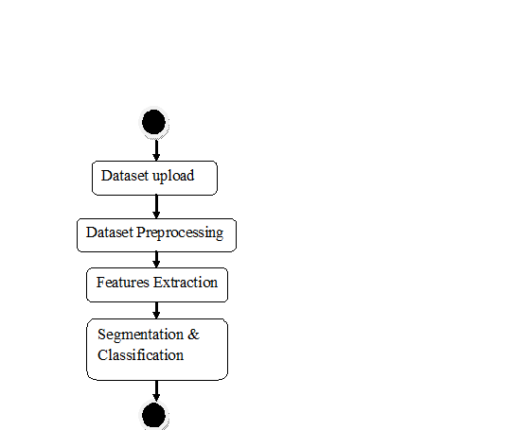
Data flow :
Data flow diagrams illustrate how data is processed by a system in terms of inputs and outputs. Data flow diagrams can be used to provide a clear representation of any business function. The technique starts with an overall picture of the business and continues by analyzing each of the functional areas of interest. This analysis can be carried out in precisely the level of detail required. The technique exploits a method called top-down expansion to conduct the analysis in a targeted way.
As the name suggests, Data Flow Diagram (DFD) is an illustration that explicates the passage of information in a process. A DFD can be easily drawn using simple symbols. Additionally, complicated processes can be easily automated by creating DFDs using easy-to-use, free downloadable diagramming tools. A DFD is a model for constructing and analyzing information processes. DFD illustrates the flow of information in a process depending upon the inputs and outputs. A DFD can also be referred to as a Process Model. A DFD demonstrates business or technical process with the support of the outside data saved, plus the data flowing from the process to another and the end results.
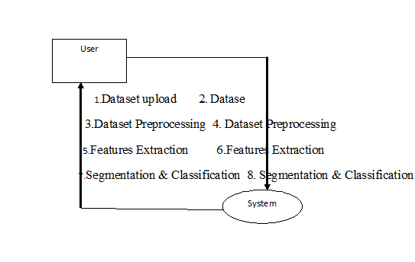

5. IMPLEMETATION
5.1 Python
Python is a general-purpose language. It has wide range of applications from Web development (like: Django and Bottle), scientific and mathematical computing (Orange, SymPy, NumPy) to desktop graphical user Interfaces (Pygame, Panda3D). The syntax of the language is clean and length of the code is relatively short. It's fun to work in Python because it allows you to think about the problem rather than focusing on the syntax.
History of Python:
Python is a fairly old language created by Guido Van Rossum. The design began in the late 1980s and was first released in February 1991.
Why Python was created?
In late 1980s, Guido Van Rossum was working on the Amoeba distributed operating system group. He wanted to use an interpreted language like ABC (ABC has simple easy-to-understand syntax) that could access the Amoeba system calls. So, he decided to create a language that was extensible. This led to design of a new language which was later named Python.
Why the name Python?
No. It wasn't named after a dangerous snake. Rossum was fan of a comedy series from late seventies. The name "Python" was adopted from the same series "Monty Python's Flying Circus".

Features of Python:
A simple language which is easier to learn
Python has a very simple and elegant syntax. It's much easier to read and write Python programs compared to other languages like: C++, Java, C#. Python makes programming fun and allows you to focus on the solution rather than syntax.
If you are a newbie, it's a great choice to start your journey with Python.
Free and open-source
You can freely use and distribute Python, even for commercial use. Not only can you use and distribute software’s written in it, you can even make changes to the Python's source code.
Python has a large community constantly improving it in each iteration.
Portability
You can move Python programs from one platform to another, and run it without any changes.
It runs seamlessly on almost all platforms including Windows, Mac OS X and Linux.
Extensible and Embeddable
Suppose an application requires high performance. You can easily combine pieces of C/C++ or other languages with Python code.
This will give your application high performance as well as scripting capabilities which other languages may not provide out of the box.
A high-level, interpreted language
Unlike C/C++, you don't have to worry about daunting tasks like memory management, garbage collection and so on.
Likewise, when you run Python code, it automatically converts your code to the language your computer understands. You don't need to worry about any lower-level operations.
Large standard libraries to solve common tasks
Python has a number of standard libraries which makes life of a programmer much easier since you don't have to write all the code yourself. For example: Need to connect MySQL database on a Web server? You can use MySQLdb library using import MySQLdb .
Standard libraries in Python are well tested and used by hundreds of people. So you can be sure that it won't break your application.
Object-oriented
Everything in Python is an object. Object oriented programming (OOP) helps you solve a complex problem intuitively.
With OOP, you are able to divide these complex problems into smaller sets by creating objects.
Applications of Python:
1. Simple Elegant Syntax
Programming in Python is fun. It's easier to understand and write Python code. Why? The syntax feels natural. Take this source code for an example:
a = 2
b = 3
sum = a + b
print(sum)

2. Not overly strict
You don't need to define the type of a variable in Python. Also, it's not necessary to add semicolon at the end of the statement.
Python enforces you to follow good practices (like proper indentation). These small things can make learning much easier for beginners.
3. Expressiveness of the language
Python allows you to write programs having greater functionality with fewer lines of code. Here's a link to the source code of Tic-tac-toe game with a graphical interface and a smart computer opponent in less than 500 lines of code. This is just an example. You will be amazed how much you can do with Python once you learn the basics.
4. Great Community and Support
Python has a large supporting community. There are numerous active forums online which can be handy if you are stuck.
5.2 Sample Code:
DepressionDetection.py

from tkinter import messagebox
from tkinter import *
from tkinter import simpledialog
import tkinter
from tkinter import filedialog
import matplotlib.pyplot as plt
import numpy as np
from tkinter.filedialog import askopenfilename
import os
import cv2
from sklearn.model_selection import train_test_split
from sklearn.metrics import accuracy_score
import imutils
from keras.utils.np_utils import to_categorical
from keras.layers import MaxPooling2D
from keras.layers import Dense, Dropout, Activation, Flatten
from keras.layers import Convolution2D
from keras.models import Sequential
from keras.models import model_from_json
import pickle
from sklearn import metrics
import ftplib
from tkinter import ttk

main = tkinter.Tk()
main.title("Identifying Bone Tumor using X-Ray Images") #designing main screen
main.geometry("1300x1200")

global filename
global accuracy
X = []
Y = []
global classifier
disease = ['No Tumor Detected','Tumor Detected']

with open('Model/segmented_model.json', "r") as json_file:
loaded_model_json = json_file.read()
segmented_model = model_from_json(loaded_model_json)
json_file.close()
segmented_model.load_weights("Model/segmented_weights.h5")
segmented_model._make_predict_function()

def edgeDetection():
img = cv2.imread('myimg.png')
orig = cv2.imread('test1.png')
gray = cv2.cvtColor(img, cv2.COLOR_BGR2GRAY)
thresh = cv2.threshold(gray, 30, 255, cv2.THRESH_BINARY)[1]
contours = cv2.findContours(thresh, cv2.RETR_TREE, cv2.CHAIN_APPROX_SIMPLE)
contours = contours[0] if len(contours) == 2 else contours[1]
min_area = 0.95*180*35
max_area = 1.05*180*35
result = orig.copy()
for c in contours:
area = cv2.contourArea(c)
cv2.drawContours(result, [c], -1, (0, 0, 255), 10)
if area > min_area and area < max_area:
cv2.drawContours(result, [c], -1, (0, 255, 255), 10)
return result

def tumorSegmentation(filename):
global segmented_model
img = cv2.imread(filename,0)
img = cv2.resize(img,(64,64), interpolation = cv2.INTER_CUBIC)
img = img.reshape(1,64,64,1)
img = (img-127.0)/127.0
preds = segmented_model.predict(img)
preds = preds[0]
print(preds.shape)
orig = cv2.imread(filename,0)
orig = cv2.resize(orig,(300,300),interpolation = cv2.INTER_CUBIC)
cv2.imwrite("test1.png",orig)
segmented_image = cv2.resize(preds,(300,300),interpolation = cv2.INTER_CUBIC)
cv2.imwrite("myimg.png",segmented_image*255)
edge_detection = edgeDetection()
return segmented_image*255, edge_detection

def uploadDataset(): #function to upload dataset
global filename
filename = filedialog.askdirectory(initialdir=".")
text.delete('1.0', END)
text.insert(END,filename+" loaded\n");

def datasetPreprocessing():
global X
global Y
X.clear()
Y.clear()
if os.path.exists('Model/myimg_data.txt.npy'):
X = np.load('Model/myimg_data.txt.npy')
Y = np.load('Model/myimg_label.txt.npy')
else:
for root, dirs, directory in os.walk(filename+"/no"):
for i in range(len(directory)):
name = directory[i]
img = cv2.imread(filename+"/no/"+name,0) #reading images
ret2,th2 = cv.threshold(img,0,255,cv.THRESH_BINARY+cv.THRESH_OTSU) #processing and normalization images
img = cv2.resize(img, (128,128)) #resizing images
im2arr = np.array(img) #extract features from images
im2arr = im2arr.reshape(128,128,1)
X.append(im2arr)
Y.append(0)
print(filename+"/no/"+name)

for root, dirs, directory in os.walk(filename+"/yes"):
for i in range(len(directory)):
name = directory[i]
img = cv2.imread(filename+"/yes/"+name,0)
ret2,th2 = cv.threshold(img,0,255,cv.THRESH_BINARY+cv.THRESH_OTSU)
img = cv2.resize(img, (128,128))
im2arr = np.array(img)
im2arr = im2arr.reshape(128,128,1)
X.append(im2arr)
Y.append(1)
print(filename+"/yes/"+name)

X = np.asarray(X)
Y = np.asarray(Y)
np.save("Model/myimg_data.txt",X)
np.save("Model/myimg_label.txt",Y)
print(X.shape)
print(Y.shape)
print(Y)
cv2.imshow('ss',X[20])
cv2.waitKey(0)
text.insert(END,"Total number of images found in dataset : "+str(len(X))+"\n")
text.insert(END,"Total number of classes : "+str(len(set(Y)))+"\n\n")
text.insert(END,"Class labels found in dataset : "+str(disease))

def trainTumorDetectionModel():
global accuracy
global classifier

YY = to_categorical(Y)

indices = np.arange(X.shape[0])
np.random.shuffle(indices)

x_train = X[indices]
y_train = YY[indices]

if os.path.exists('Model/model.json'):
with open('Model/model.json', "r") as json_file:
loaded_model_json = json_file.read()
classifier = model_from_json(loaded_model_json)

classifier.load_weights("Model/model_weights.h5")
classifier._make_predict_function()
else:
X_trains, X_tests, y_trains, y_tests = train_test_split(x_train, y_train, test_size = 0.2, random_state = 0)
classifier = Sequential()
classifier.add(Convolution2D(32, 3, 3, input_shape = (128, 128, 1), activation = 'relu'))
classifier.add(MaxPooling2D(pool_size = (2, 2)))
classifier.add(Convolution2D(32, 3, 3, activation = 'relu'))
classifier.add(MaxPooling2D(pool_size = (2, 2)))
classifier.add(Flatten())
classifier.add(Dense(output_dim = 128, activation = 'relu'))
classifier.add(Dense(output_dim = 2, activation = 'softmax'))
print(classifier.summary())
classifier.compile(optimizer = 'adam', loss = 'categorical_crossentropy', metrics = ['accuracy'])
hist = classifier.fit(x_train, y_train, batch_size=16, epochs=10,validation_split=0.2, shuffle=True, verbose=2)
classifier.save_weights('Model/model_weights.h5')
model_json = classifier.to_json()
with open("Model/model.json", "w") as json_file:
json_file.write(model_json)
f = open('Model/history.pckl', 'wb')
pickle.dump(hist.history, f)
f.close()
f = open('Model/history.pckl', 'rb')
data = pickle.load(f)
f.close()
acc = data['accuracy']
accuracy = acc[4] * 100
text.insert(END,'\n\nCNN Bone Tumor Model Generated. See black console to view layers of CNN\n\n')
text.insert(END,"CNN Bone Tumor Prediction Accuracy on Test Images : "+str(accuracy)+"\n")

def tumorClassification():
filename = filedialog.askopenfilename(initialdir="testImages")
img = cv2.imread(filename,0)
img = cv2.resize(img, (128,128))
im2arr = np.array(img)
im2arr = im2arr.reshape(1,128,128,1)
XX = np.asarray(im2arr)

predicts = classifier.predict(XX)
print(predicts)
cls = np.argmax(predicts)
print(cls)
if cls == 0:
img = cv2.imread(filename)
img = cv2.resize(img, (800,500))
cv2.putText(img, 'Classification Result : '+disease[cls], (10, 25), cv2.FONT_HERSHEY_SIMPLEX,0.7, (0, 255, 255), 2)
cv2.imshow('Classification Result : '+disease[cls], img)
cv2.waitKey(0)
if cls == 1:
segmented_image, edge_image = tumorSegmentation(filename)
img = cv2.imread(filename)
img = cv2.resize(img, (800,500))
cv2.putText(img, 'Classification Result : '+disease[cls], (10, 25), cv2.FONT_HERSHEY_SIMPLEX,0.7, (0, 255, 255), 2)
cv2.imshow('Classification Result : '+disease[cls], img)
cv2.imshow("Tumor Segmented Image",segmented_image)
cv2.imshow("Edge Detected Image",edge_image)
cv2.waitKey(0)
def graph():
f = open('model/history.pckl', 'rb')
data = pickle.load(f)
f.close()
accuracy = data['accuracy']
loss = data['loss']

plt.figure(figsize=(10,6))
plt.grid(True)
plt.xlabel('Training Epoch')
plt.ylabel('Accuracy/Loss')
plt.plot(loss, 'ro-', color = 'red')
plt.plot(accuracy, 'ro-', color = 'green')
plt.legend(['Loss', 'Accuracy'], loc='upper left')
plt.title('Bone Tumor CNN Model Training Accuracy & Loss Graph')
plt.show()

font = ('times', 16, 'bold')
title = Label(main, text='Identifying Bone Tumor using X-Ray Images')
title.config(bg='darkviolet', fg='gold')
title.config(font=font)
title.config(height=3, width=120)
title.place(x=0,y=5)

font1 = ('times', 12, 'bold')
text=Text(main,height=20,width=150)
scroll=Scrollbar(text)
text.configure(yscrollcommand=scroll.set)
text.place(x=50,y=120)
text.config(font=font1)

font1 = ('times', 12, 'bold')
uploadButton = Button(main, text="Upload Tumor X-Ray Images Dataset", command=uploadDataset)
uploadButton.place(x=50,y=550)
uploadButton.config(font=font1)

preprocessButton = Button(main, text="Dataset Preprocessing & Features Extraction", command=datasetPreprocessing)
preprocessButton.place(x=430,y=550)
preprocessButton.config(font=font1)

cnnButton = Button(main, text="Trained CNN Bone Tumor Detection Model", command=trainTumorDetectionModel)
cnnButton.place(x=810,y=550)
cnnButton.config(font=font1)

classifyButton = Button(main, text="Bone Tumor Segmentation & Classification", command=tumorClassification)
classifyButton.place(x=50,y=600)
classifyButton.config(font=font1)

graphButton = Button(main, text="Training Accuracy Graph", command=graph)
graphButton.place(x=430,y=600)
graphButton.config(font=font1)

main.config(bg='turquoise')
main.mainloop()

6. TESTING:
Implementation and Testing:
Implementation is one of the most important tasks in project is the phase in which one has to be cautions because all the efforts undertaken during the project will be very interactive. Implementation is the most crucial stage in achieving successful system and giving the users confidence that the new system is workable and effective. Each program is tested individually at the time of development using the sample data and has verified that these programs link together in the way specified in the program specification. The computer system and its environment are tested to the satisfaction of the user.

Implementation

The implementation phase is less creative than system design. It is primarily concerned with user training, and file conversion. The system may be requiring extensive user training. The initial parameters of the system should be modifies as a result of a programming. A simple operating procedure is provided so that the user can understand the different functions clearly and quickly. The different reports can be obtained either on the inkjet or dot matrix printer, which is available at the disposal of the user. The proposed system is very easy to implement. In general implementation is used to mean the process of converting a new or revised system design into an operational one.

Testing
Testing is the process where the test data is prepared and is used for testing the modules individually and later the validation given for the fields. Then the system testing takes place which makes sure that all components of the system property functions as a unit. The test data should be chosen such that it passed through all possible condition. Actually testing is the state of implementation which aimed at ensuring that the system works accurately and efficiently before the actual operation commence. The following is the description of the testing strategies, which were carried out during the testing period.

System Testing
Testing has become an integral part of any system or project especially in the field of information technology. The importance of testing is a method of justifying, if one is ready to move further, be it to be check if one is capable to with stand the rigors of a particular situation cannot be underplayed and that is why testing before development is so critical. When the software is developed before it is given to user to use the software must be tested whether it is solving the purpose for which it is developed. This testing involves various types through which one can ensure the software is reliable. The program was tested logically and pattern of execution of the program for a set of data are repeated. Thus the code was exhaustively checked for all possible correct data and the outcomes were also checked.
Module Testing
To locate errors, each module is tested individually. This enables us to detect error and correct it without affecting any other modules. Whenever the program is not satisfying the required function, it must be corrected to get the required result. Thus all the modules are individually tested from bottom up starting with the smallest and lowest modules and proceeding to the next level. Each module in the system is tested separately. For example the job classification module is tested separately. This module is tested with different job and its approximate execution time and the result of the test is compared with the results that are prepared manually. The comparison shows that the results proposed system works efficiently than the existing system. Each module in the system is tested separately. In this system the resource classification and job scheduling modules are tested separately and their corresponding results are obtained which reduces the process waiting time.
Integration Testing
After the module testing, the integration testing is applied. When linking the modules there may be chance for errors to occur, these errors are corrected by using this testing. In this system all modules are connected and tested. The testing results are very correct. Thus the mapping of jobs with resources is done correctly by the system.
Acceptance Testing
When that user fined no major problems with its accuracy, the system passers through a final acceptance test. This test confirms that the system needs the original goals, objectives and requirements established during analysis without actual execution which elimination wastage of time and money acceptance tests on the shoulders of users and management, it is finally acceptable and ready for the operation.

Test Case Id | Test Case Name | Test Case Desc. | Test Steps |  |  |  | Test Case Status | Test Priority
 |  |  | Step | Expected |  | Actual
O1 | Dataset upload | Verify  Dataset updated or not | If  dataset is May not be Uploaded | we cannot do any further operations | we can do further operations |  | High | High
02 | Dataset Preprocessing | Verify preprosser dataset is updated or not | If preprosser  Dataset is may not be Updated | we cannot do any further operations | we can do further operations |  | High | High
03 | Features Extraction | Verify Features Extraction Sucessfully or not | If Features Extraction is may not be Run Sucessfully | We cannot run  operation | We can Run the Operation |  | High | High
04 | Segmentation & Classification | Verify Segmentation & Classification successfully or not | If Segmentation & Classification may not run Sucessfully | We cannot run  operation | We can Run the Operation |  | High | High
7. SCREENSHOTS:
Identifying Bone Tumor using X-Ray Images
In this project we are implementing deep learning Convolution Neural Network (CNN) to predict bone tumor and to train this algorithm we have used bone images with and without tumor.

To implement this project we have used below dataset

In above screen we have 2 folders called ‘no and yes’ where no folder contains normal bone images and ‘yes’ folder contains bone tumor images and just go inside any folder to view images like below screen
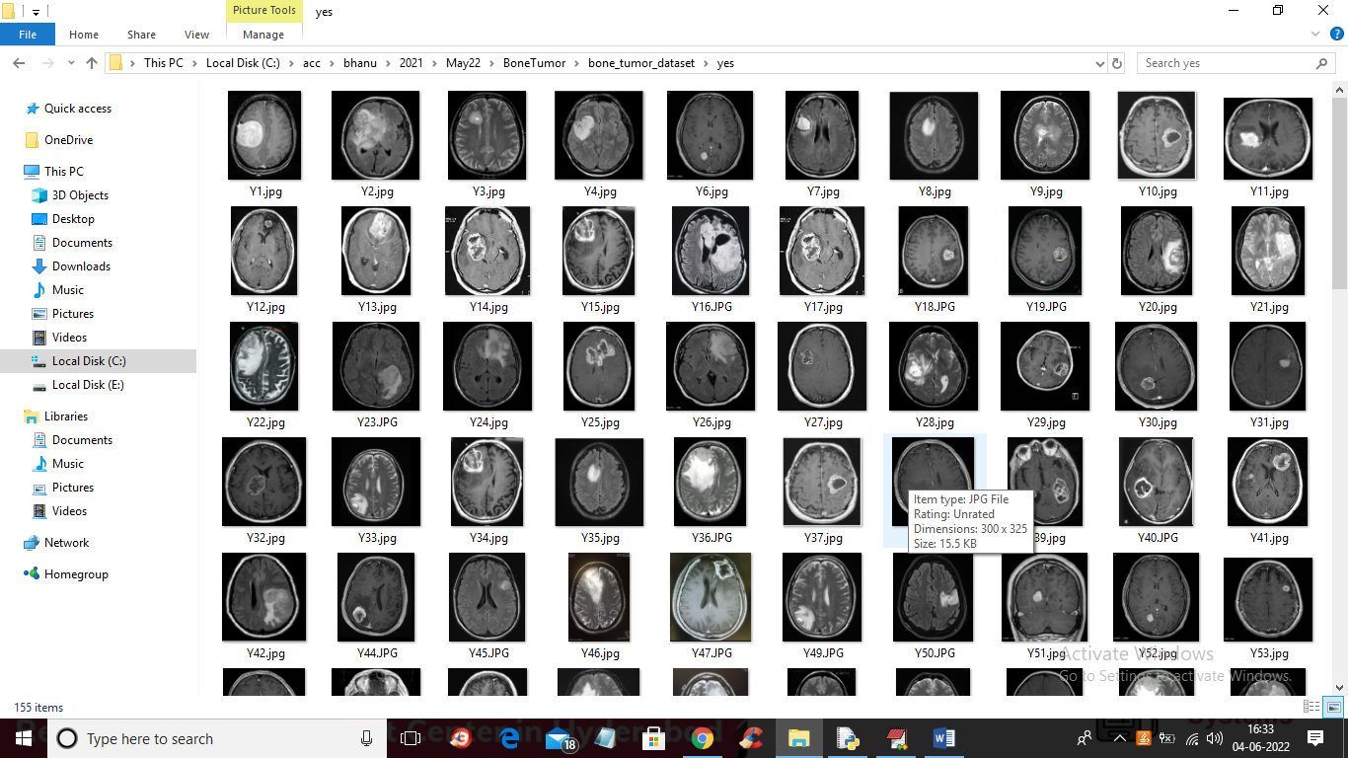
We are using above images to train CNN for tumor detection
SCREEN SHOTS
To run project double click on run.bat file to get below screen
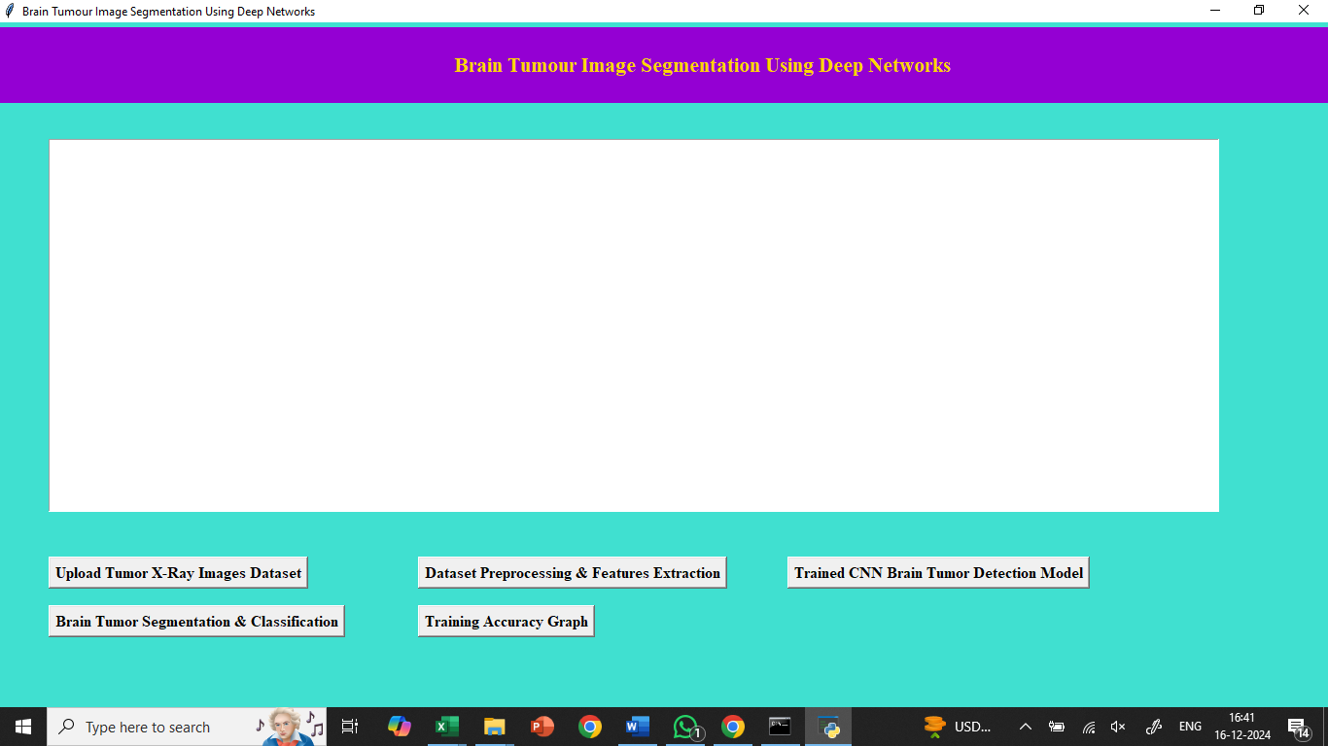
In above screen click on ‘Upload Tumor X-Ray Images Dataset’ button to upload X-Ray images dataset and get below output
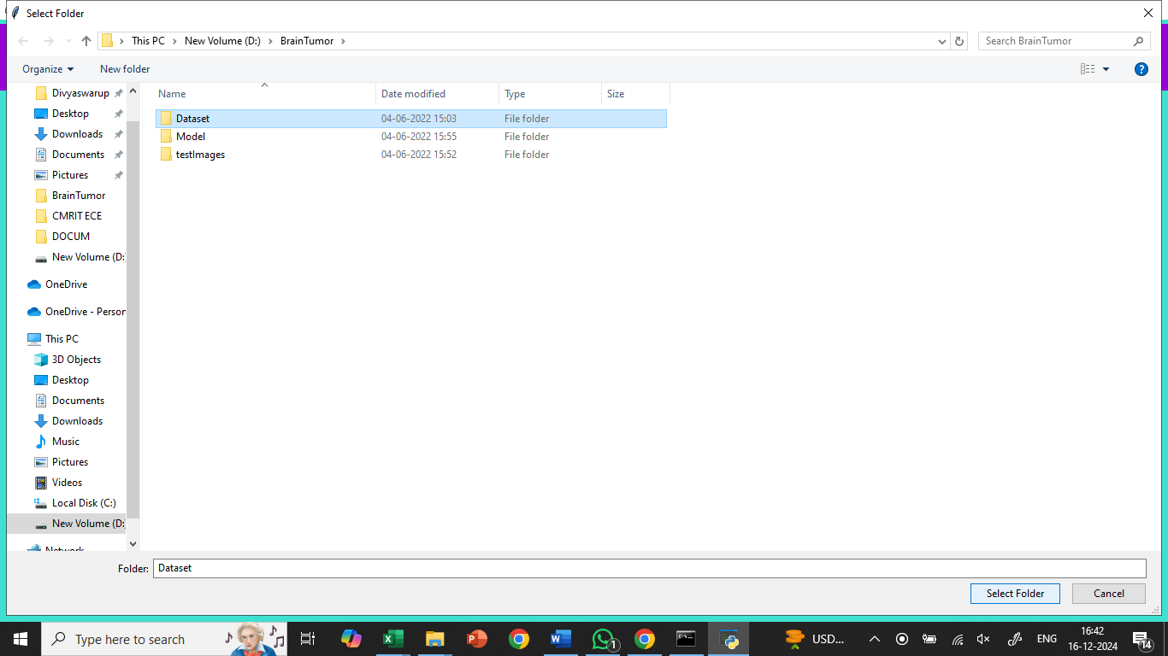
In above screen selecting and uploading brain tumor dataset and then click on ‘Select Folder’ button to load dataset and then get below output
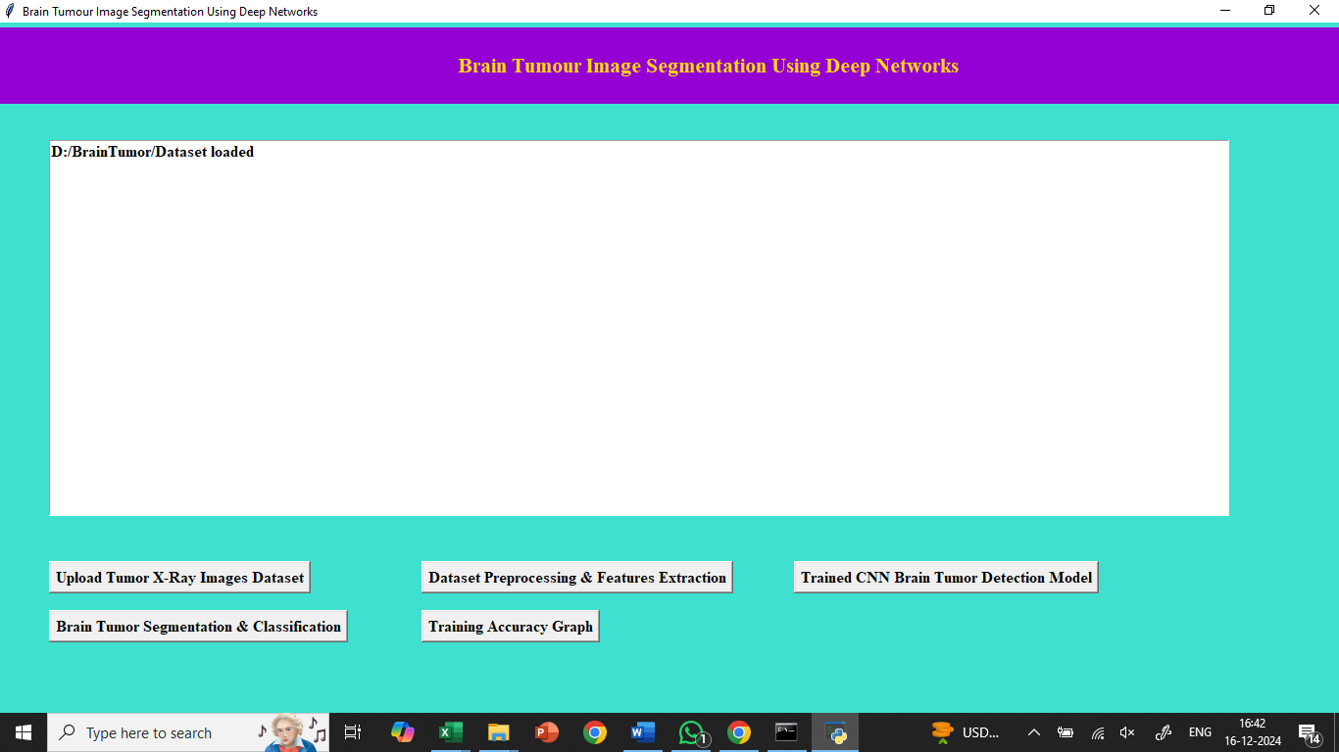
In above screen dataset loaded and now click on ‘Dataset Preprocessing & Features Extraction’ button to read all images and then process and extract features to train with CNN
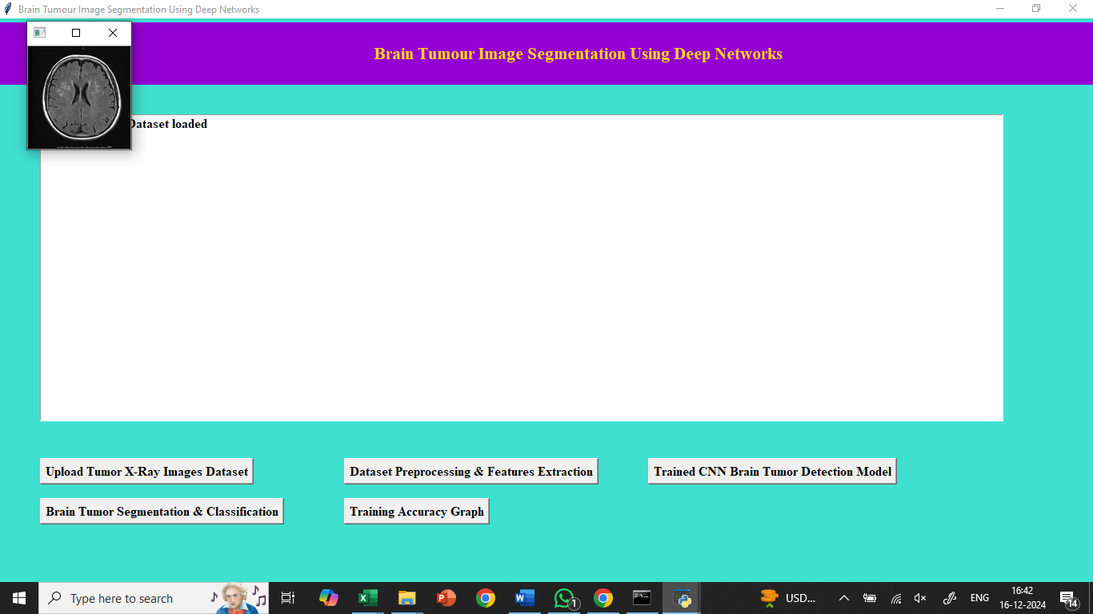
In above screen all images are processed and to check images are loaded properly so I am displaying one sample processed image and now close that image to get below output
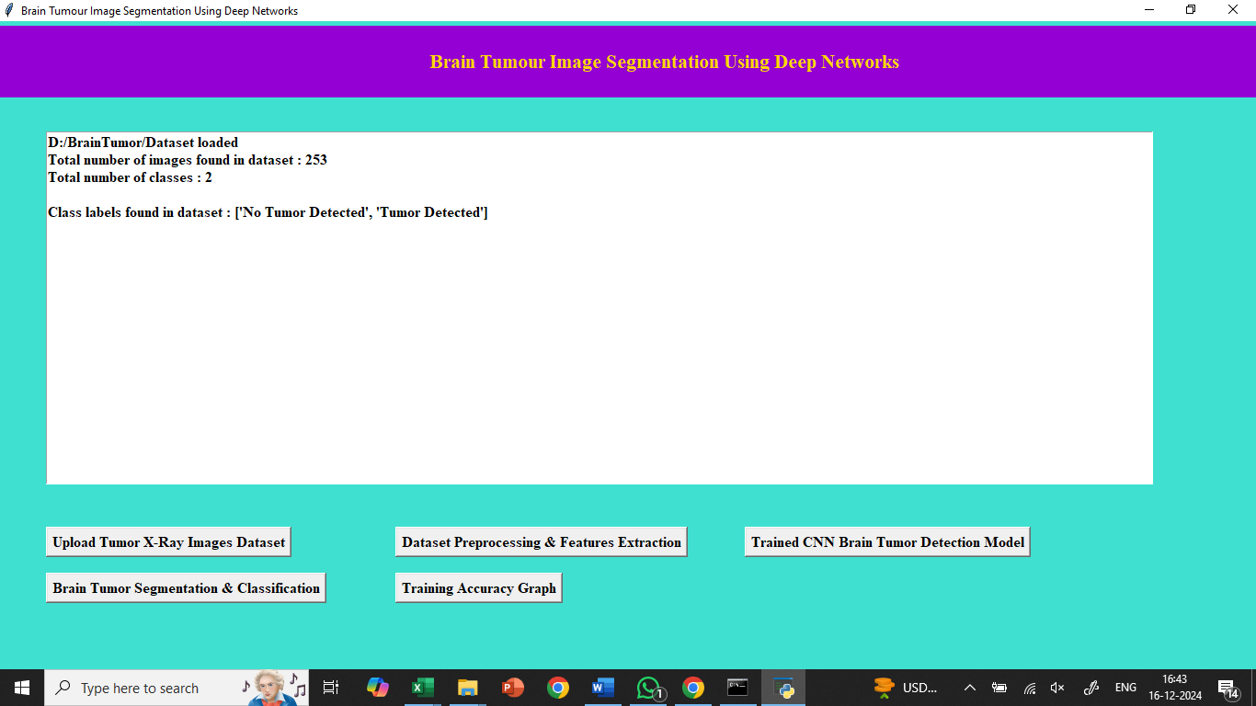
In above screen we can see dataset contains 253 images with and without tumor class label and now click on ‘Trained CNN Bone Tumor Detection Model’ button to train CNN with above extracted features and get below output
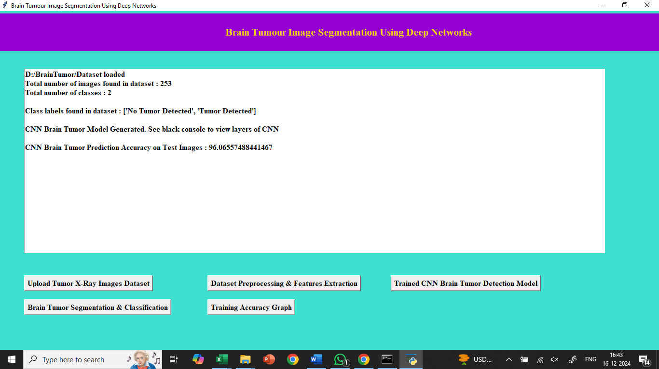
In above screen CNN training completed and we got it accuracy as 96% and now click on ‘Bone Tumor Segmentation & Classification’ button to upload test image and get below output
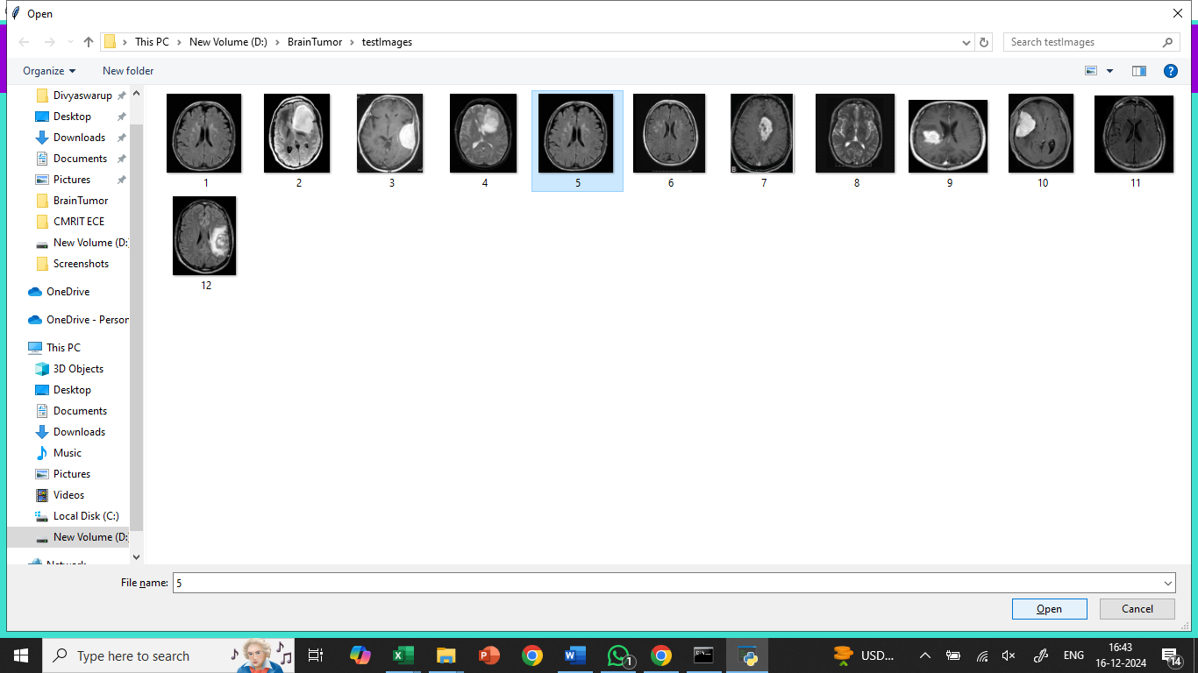
In above screen selecting and uploading 5.jpg file and then click on ‘Open’ button to get below output
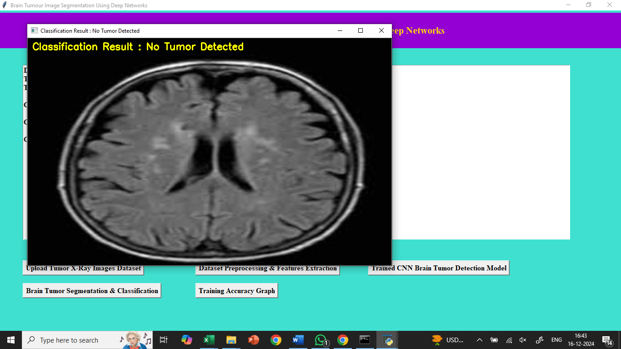
In above image ‘No Tumor Detected’ and now try another image
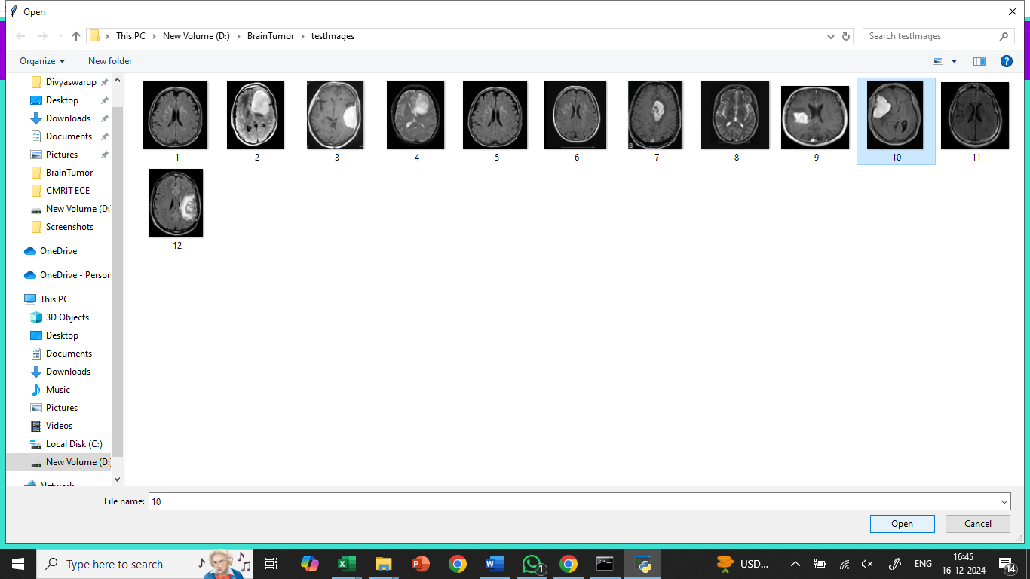
In above screen selecting and uploading ’10.jpg’ and then click on ‘Open’ button to get below output
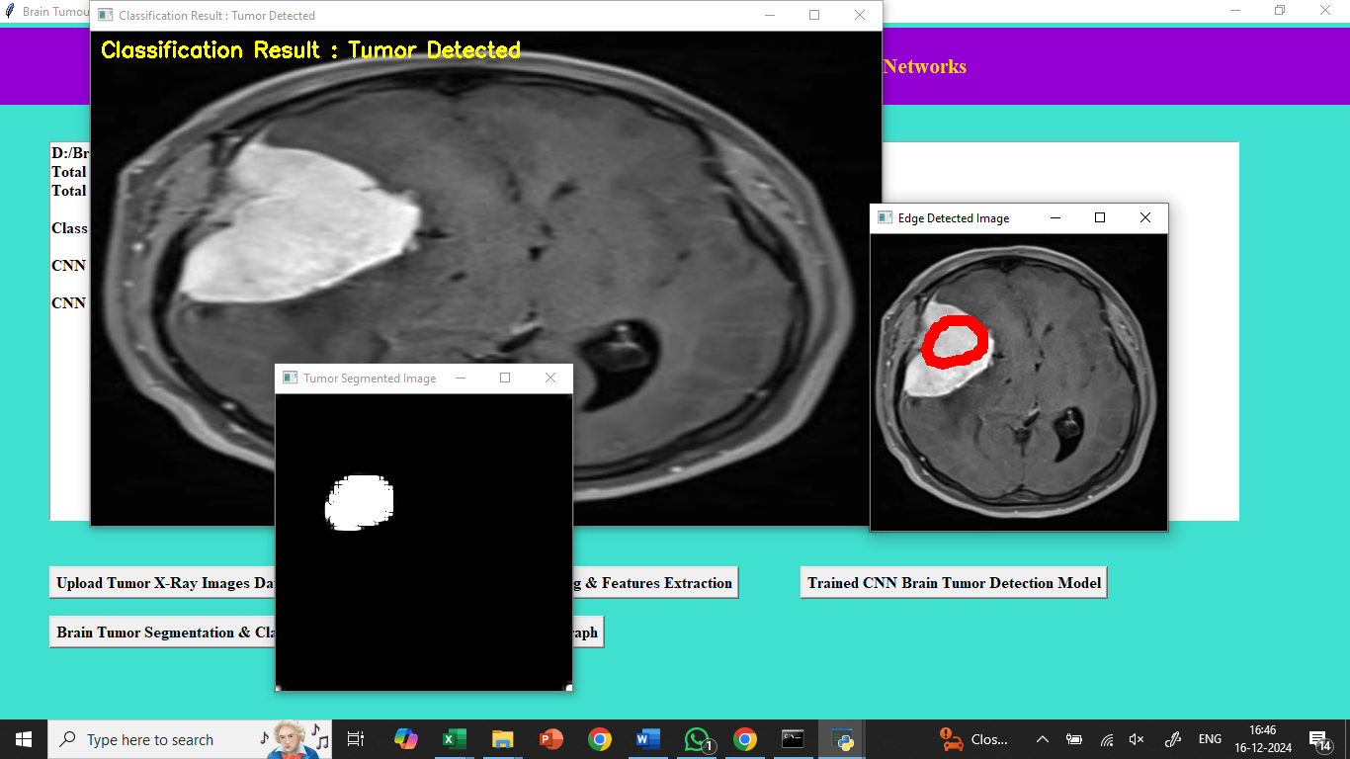
In above screen first image is the original image which classified as tumor detected and second image is tumor segmented image and 3rd image is the tumor edge detected image and see another image is below screen
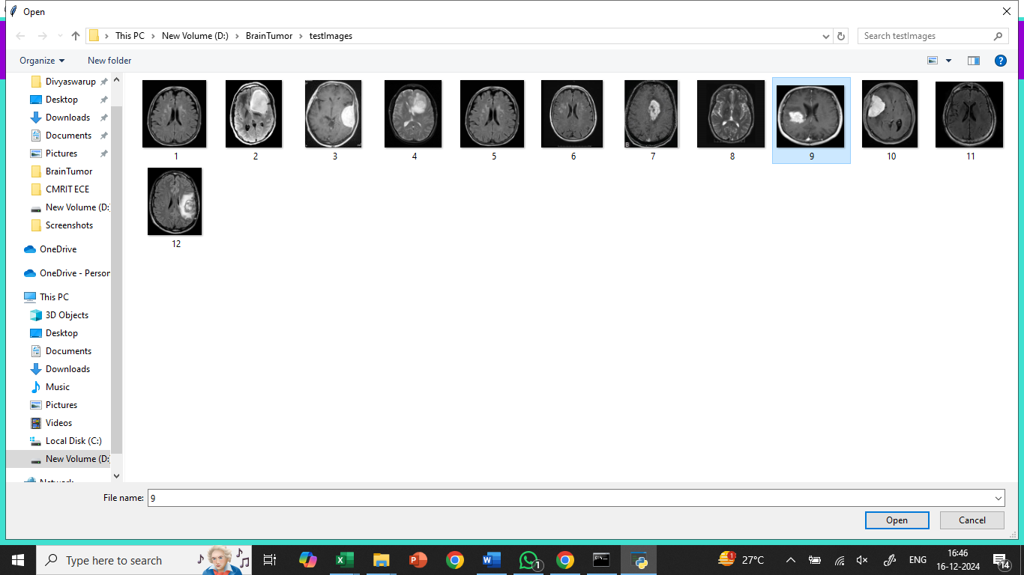
In above screen uploading 9.jpg image and click open button to get below output
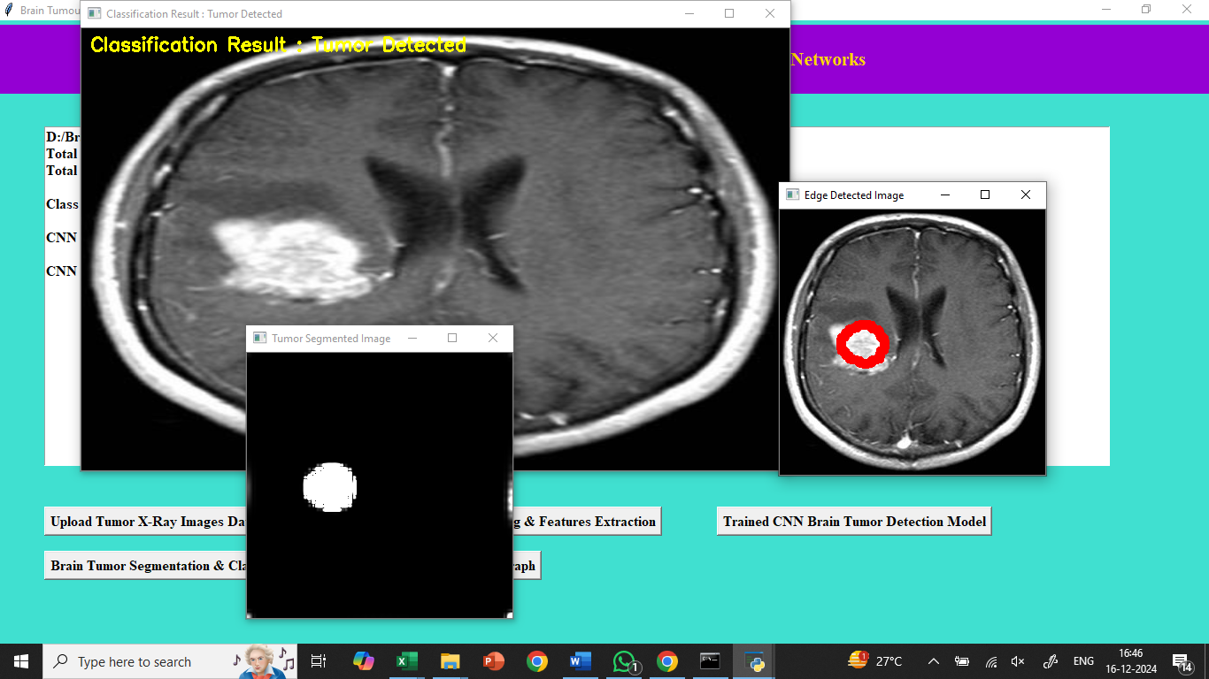
In above screen we can see tumor detected with segmented out tumor image and with tumor edge detected. Similarly you can upload other images and test and now click on ‘Training Accuracy Graph’ button to get below graph
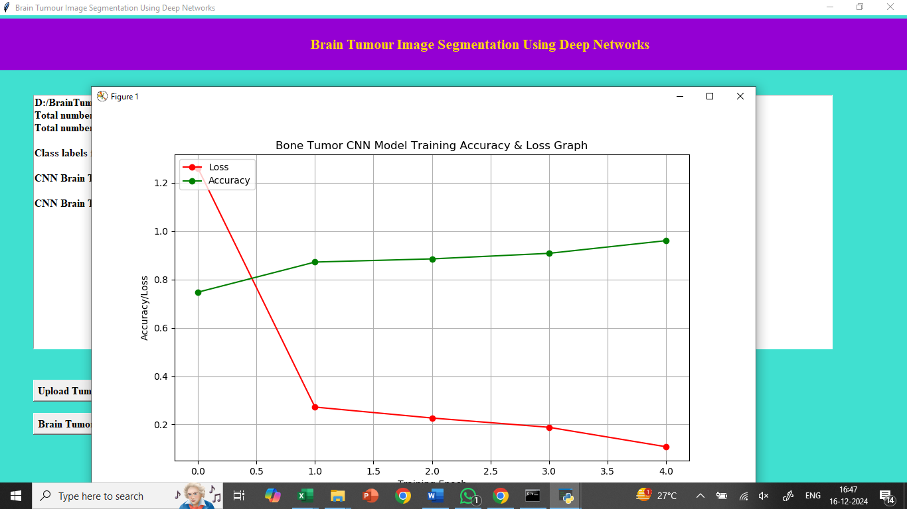
In above graph x-axis represents training EPOCH and y-axis represents training accuracy and loss values and green line representing accuracy and red line represents LOSS and in above graph we can see with each increasing epoch accuracy got increase and loss got decrease

8. CONCLUSION:
In this work, we have proposed a technique for automated long-bone cancer diagnosis for the first time that is solely based on the analysis of an input X-ray image. The proposed method integrates several interdisciplinary concepts such as statistical runs-test, local entropy- and standard deviation-based tools, digital-geometric analysis, SVM classification, and decision tree. The notion of ortho-convex cover of a cluster of marked pixels is used for convenient visualization and diagnosis of the disease and for grading the severity of cancer-affected regions. The use of digital-geometric tools leads to a fast estimation of the area of ROI as the required computation needs only integer-domain operations. Experimental results on a medical database of healthy and cancer-affected X-ray images reveal that the proposed method is fairly accurate as AUC for bone cancer detection is more than 0.85. Further, in 85% of cases, the bone-destruction pattern, stage, and grade of cancer predicted by the automated tool correctly match with the actual findings as judged by the doctors and medical professionals

9. REFERENCES:
1. American Joint Committee on Cancer (AJCC) AJCC cancer staging manual vol 17(6). Springer-Verlag (2010)
2. Alelyani S, Tang J, Liu H: Feature selection for clustering: a review. In: Data clustering: Algorithms and applications, vol 29, pp 110–121. CRC Press, 2013
3. Bandyopadhyay O, Biswas A, Bhattacharya BB: Long-bone fracture detection in digital X-ray images based on digital-geometric techniques. Comput Methods Programs Biomed 123:2–14, 2016 [PubMed]
4. Bandyopadhyay O, Chanda B, Bhattacharya BB: Automatic segmentation of bones in X-ray images based on entropy measure. Int J Image Graph 16(1):1650,001–32, 2016
5. Bennett JR, Donald JSM: On the measurement of curvature in a quantized environment. IEEE Trans Comput 24(8):803–820, 1975
6. Bourouis S, Chennoufi I, Hamrouni K: Multimodal bone cancer detection using fuzzy classification and variational model. In: Proceedings, IAPR, vol LNCS 8258, pp 174–181, 2013
7. Brant WE, Helms CA. Fundamentals of diagnostic radiology. Philadelphia: Wolters Kluwer; 2007. [Google Scholar]
8. Burges CJC: A tutorial on support vector machines for pattern recognition. Data Min Knowl Disc 2:121–167, 1998
9. Criminisiand A, Shotton J. Decision forests for computer vision and medical image analysis. London: Springer; 2013. [Google Scholar]
10. Dillencourt MB, Samet H: A general approach to connected component labeling for arbitrary image representations. J ACM 39:253–280, 1992
11. Ehara S: MR Imaging in staging of bone tumors. J Cancer Imaging 6:158–162, 2006 [PMC free article] [PubMed]
12. Frangi A, Egmont-Petersen M, Niessen W, Reiber J, Viergever M: Segmentation of bone tumor in MR perfusion images using neural networks and multiscale pharmacokinetic features. Image Vis Comput 19:679–690, 2001
13. Freeman H: On the encoding of arbitrary geometric configurations. IRE Trans Electron Comput 10:260–268, 1961
14. Hastie T, Tibshirani R, Friedman J. The elements of statistical learning. London: Springer; 2009. [Google Scholar]
15. Heidl W, Thumfart S, Lughofer E, Eitzinger C, Klement EP: Machine learning based analysis of gender differences in visual inspection decision making. Inf Sci 224:62–76, 2013
16. Heymann D. Bone cancer. Cambridge: Academic Press; 2015. [Google Scholar]
17. Hsu C, Chang C, Lin C (2003) Practical guide to support vector classification. http://www.csie.ntu.edu.tw/cjlin/papers.html
18. Huang S, Chiang K: Automatic detection of bone metastasis in vertebrae by using CT images. In: Proceedings, world congress on engineering, vol 2, pp 1166–1171, 2012
19. Leven RI, Rubin DS, Rastogi S, Siddiqui MS. Statistics for management. India: Pearson; 2012. [Google Scholar]
20. Maulik U, Chakraborty D: Fuzzy preference based feature selection and semisupervised SVM for cancer classification. IEEE Trans NanoBiosciences 13(2):152–160, 2014 [PubMed]
21. Nandy SC, Mukhopadhyay K, Bhattacharya BB: Recognition of largest empty orthoconvex polygon in a point set. Inf Process Lett 110(17):746–752, 2010
22. Nisthula P, Yadhu RB: A novel method to detect bone cancer using image fusion and edge detection. Int J Eng Comput Sci 2(6):2012–2018, 2013
23. Ping YY, Yin CW, Kok LP: Computer aided bone tumor detection and classification using X-ray images. In: Proceedings, international federation for medical and biological engineering, pp 544–557, 2008
24. Popovic A, Fuente MDL, Engelhardt M, Radermacher K: Statistical validation metric for accuracy assessment in medical image segmentation. International Journal of Computer Assisted Radiology and Surgery 2(4):169–181, 2007
25. Powers D: Evaluation: From precision, recall and F-Measure to ROC, Informedness, Markedness & Correlation. J Mach Learn Technol 2(1):37–63, 2007
26. Roobaert D, Karakoulas G, Chawla NV (2006) Information gain correlation and support vector machines
27. Vapnik VN, Chervonenkis AY: On the uniform convergence of relative frequencies of events to their probabiloties. Theory of Probability and its Applications 16(2):264–280, 1971
28. Yao J, O’Connor SD, Summer R: Computer aided lytic bone metastasis detection using regular CT images. In: Proceedings, SPIE medical imaging, pp 1692–1700, 2006
29. Zhu W, Zeng N, Wang W: Sensitivity, specificity, accuracy, associated confidence interval and roc analysis with practical SAS® implementations. In: Proceedings NESUG: Health and Life Sciences, pp 1–9, 2010

